Assessment Schedule – 2015
Mathematics and Statistics: Investigate relationships between tables, equations and graphs (91028)
Evidence Statement
One | Expected coverage | Achievement | Merit | Excellence
(a)(i) | Exponential curve, starting at (3,4) and curving smoothly to (8,128).  (See Appendix A.) | Correct curve drawn, using discrete points or continuous curve.
(ii) | 1 m², which means that 2 days before he started measuring, there was already a patch of plant 1 m² in area. | Correct value identified. | Valid interpretation of the answer given.
(iii) | A = 0.5 × 2^{d}  OR A = 2^{d – 1} |  | A = 2^{d} | Correct equation.
(iv) | 10 days | Correct answer.
(b)(i) | A = –25.6d + 332.8 | Correct gradient  OR  Correct intercept. | Correct equation.
(ii) | Grade levels are independent relating to their understanding of the nature of the points. So the evidence provided is not related to an earlier criterion.  They might not be able to remove exactly the same amount of plant each day.  It would not be a straight line since the amount it grew back would be bigger when there was more plant. | Comment relates people’s ability to remove plant to the graph’s gradient. |  | Comment develops how the slope might vary over the 5 days (with justification).

NØ | N1 | N2 | A3 | A4 | M5 | M6 | E7 | E8
No response or no relevant evidence | Some relevant evidence. | 1u | 2u | 3u | 1r | 2r | 1t | 2t

Two | Expected coverage | Achievement | Merit | Excellence
(a) | 10 m² | Correct response.
(b) | 18 days | Correct response. | Correct response with correct working.
(c)(i)  (ii) | Equation given as A = 90  It means  - The amount of plant is staying the same.  - The rate of removal is keeping pace with the growth. | Correct equation. | Correct equation.  AND  Makes one point.
(d)(i) | Line drawn has slope of –15 and starts at (9,90). | Correct line drawn.
(ii) | Day 15 | Correct response given.
(e) | If original equation is  A = 225 – 15d,  the new one will be  A = 225 – 15(d + 2)  = –15d + 195  Since it needs to be shifted 2 days to the left. | y = 210 – 15d  acceptable | Correct equation. | Correct equation and complete description of rationale behind the new equation in terms of translation of the graph.
(f) |  | TWO correct of: |  | Correct equation.
(f) | 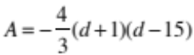 ^ | - Factor of –4/3  - (d + 1)  - (d – 15) |  | Correct equation.
(f) | 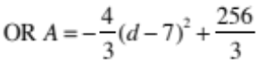 | - Factor of –4/3  - (d – 7)  - 256/3 or 85.333 |  | Correct equation.
(f) | 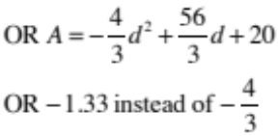  OR GC answer  A = –1.3x² + 18.66x + 19.99 | Two terms correct. |  | Correct equation.

NØ | N1 | N2 | A3 | A4 | M5 | M6 | E7 | E8
No response or no relevant evidence | Some relevant evidence. | 1u | 2u | 3u | 1r | 2r | 1t | 2t

Three | Expected coverage | Achievement | Merit | Excellence
(a)
  x | A = x + 1 | B = x – 4 | y = AB
  0 | 1 | –4 | –4
  1 | 2 | –3 | –6
  2 | 3 | –2 | –6
  3 | 4 | –1 | –4
  4 | 5 | 0 | 0
(i) | 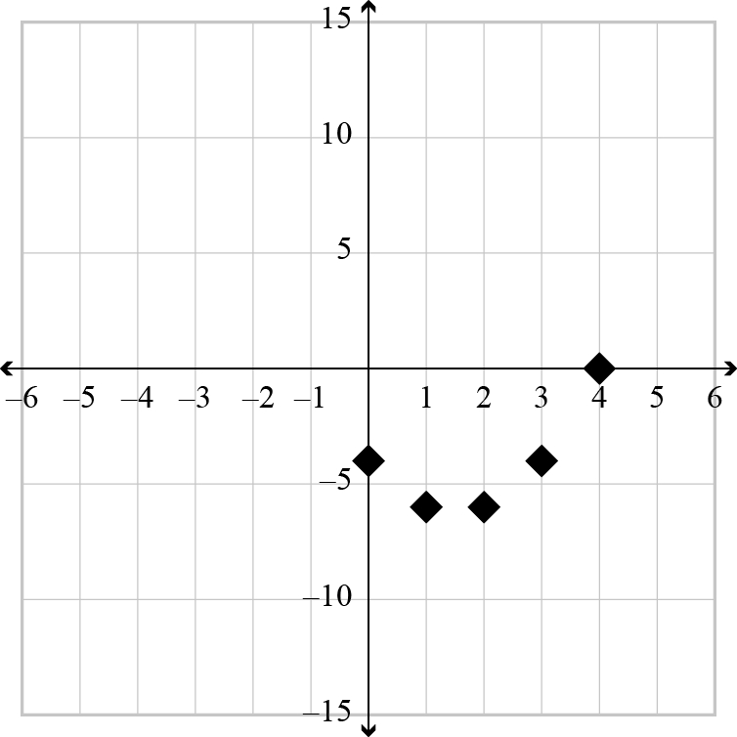 | Correct parabola drawn but curve used. | Discrete graph of correct parabola drawn.
(ii) | y = (x + 1)(x – 4)  OR y = x² – 3x – 4  OR y = (x – 1.5)² – 6.25 |  | Correct equation.
(iii) | The solutions will be where the curve reaches a height of 6 (or hits the line y = 6). This will happen when x = 5.  Since a parabola is symmetrical, this will happen twice, once at x = 5, and the other time when  x = –2.  [Graph shown completed for –2 < x < 0] | One solution obtained and explained.  OR  Two solutions. |  | Clear explanation for why there are two solutions from graph. Does not have to have solutions.
(iv) | Since the graph never drops to a height of –10, we can see that there will be no (real) solutions. | Acknowledges  impossibility. | Complete, clear explanation.
(b)(i) | y = 4x – 100  OR other variables. | Correct equation.
(ii) | Graph of y = 4x – 100 | Drawn correctly
(iii) | You could find the solution by plotting  y = 1.12(x + 47) on the same axes and looking for the point of intersection. This may be difficult to do accurately.  Solution is x = 53. | Correct graph of  y = 1.12(x + 47) or use of that equation in response.  OR correct equation.  OR answer only. | Estimate of the solution read off the graph to give 50 < x < 55. | Exact solution obtained by refining the graph estimate or by algebra.

NØ | N1 | N2 | A3 | A4 | M5 | M6 | E7 | E8
No response or no relevant evidence | Some relevant evidence. | 1u | 2u | 3u | 1r | 2r | 1t | 2t

Cut Scores
Not Achieved | Achievement | Achievement with Merit | Achievement with Excellence
0 – 8 | 9 – 14 | 15 – 19 | 20 – 24

Appendix A – Question One (a)
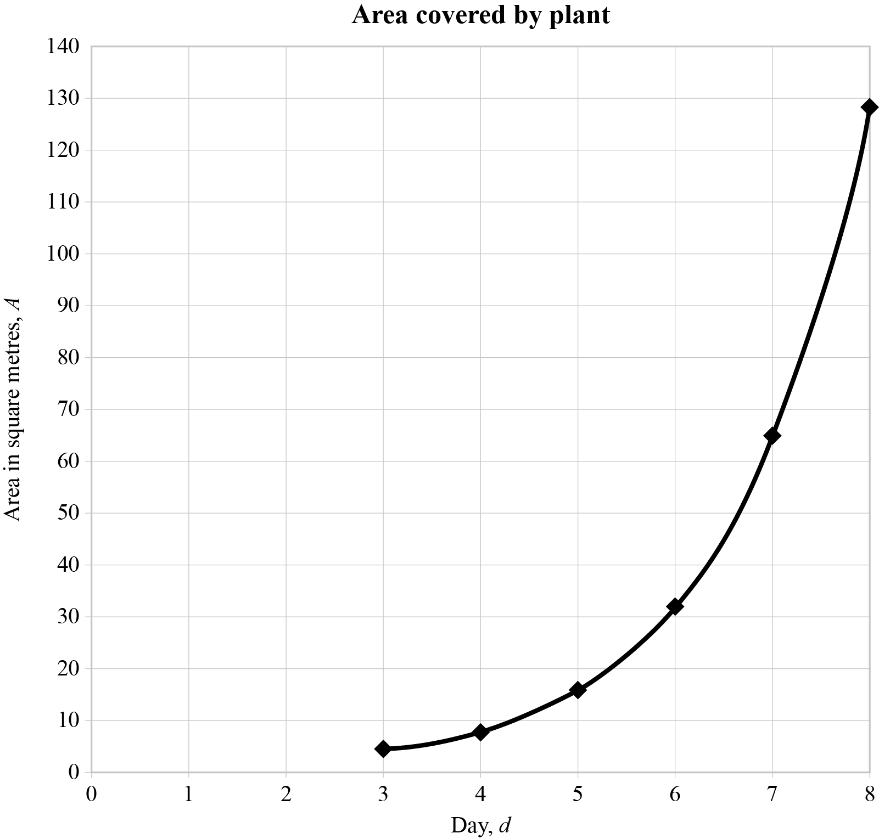

Appendix B – Question Three (b)(ii) and (iii)

